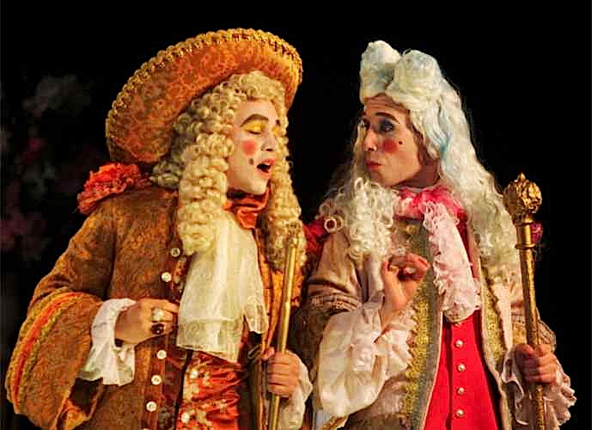
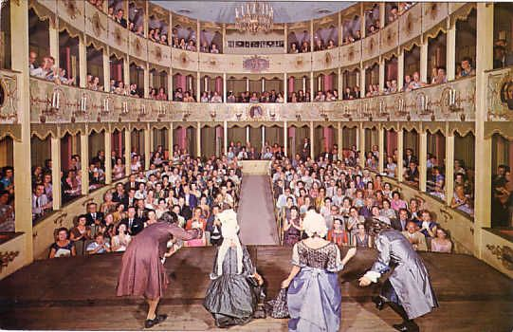

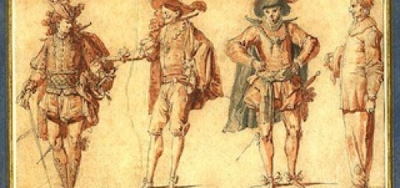
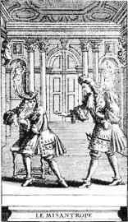
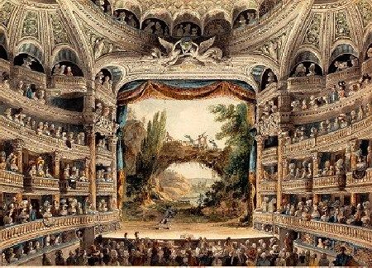
Restoration Theatre
or
Comedy of Manners
1660 - 1800
Restoration Theatre 1660 – 1800
The Elizabethan period ran from 1562 until 1642 when there was a ban on public performances enforced by parliament. The Puritans came to power and thought entertainment was sinful. The performance of plays was banned for most of the next 18 years.
Charles II (1660 – 1685) was restored to the throne in 1660 and the theatres re-opened. He had spent his time abroad in France at the court of Louis XIV, who loved theatre. Charles II helped bring Italian and French styles and staging to England. However, he issued only two patents for new theatre companies – The Duke’s Men (run by William Davenant,) and The King’s Company (Thomas Killigrew) and their monopoly on performances hampered the growth of British theatre. A Restoration acting company was owned and controlled by one man: the manager. He usually was the leading actor of the company, and chose those plays which best exhibited his abilities. The remainder of the acting company was hired and did not share in the company's profit (or loss). Actors were paid according to their popularity and usually played one type of role only.
The two companies performed many of the plays of the previous era, though in adapted forms. But the period also saw the emergence of a new genre – the Restoration comedy or Comedy of Manners. Restoration comedy is notorious for its sexual explicitness, a quality encouraged by Charles II personally and by the rakish aristocratic ethos of his court. Charles was popularly known as the Merry Monarch, in reference to both the liveliness and hedonism of his court and the general relief at the return to normality after over a decade of rule by Oliver Cromwell and the Puritans.
The socially diverse audiences included both aristocrats, their servants and hangers-on, and a substantial middle-class segment. These playgoers were attracted to the comedies by up-to-the-minute topical writing, by crowded and bustling plots, by the introduction of the first professional actresses, and by the rise of the first celebrity actors. This period saw the first professional woman playwright, Aphra Behn.
Restoration comedy was strongly influenced by the introduction of the first professional actresses. Before the closing of the theatres, all female roles had been played by boys, and the predominantly male audiences of the 1660s and 1670s were curious, censorious, and delighted at the novelty of seeing real women engage in risqué repartee and take part in physical seduction scenes. Daringly suggestive comedy scenes involving women became especially common. A new specialty introduced almost as early as the actresses was the breeches role, which called for an actress to appear in male clothes (breeches being tight-fitting knee-length pants, the standard male garment of the time), for instance to play a witty heroine who disguises herself as a boy to hide, or to engage in escapades disallowed to girls. A quarter of the plays produced on the London stage between 1660 and 1700 contained breeches roles. Charles II's mistress Nell Gwyn was a successful Restoration actress. For the first time, actors and actresses became public personalities and celebrities.
Variety and dizzying fashion changes are typical of Restoration comedy

Plot and Themes
Comedy of Manners dealt with the fashions of the upper class – it poked fun at them, drew attention to their concern for social appearance. Drew attention to the fact that behind closed doors the upper class wasn't so "classy"
The plays ridiculed human failings and the breaches of a "sophisticated code of manners" established by the courtiers of Charles II. They assumed (but never stated) an ideal mode of life which they expected the audience to accept.
Common themes suggest several social anxieties of the time. Cuckolding is a recurring theme that suggests men were concerned with their reputation and the possibility of being made a fool by their wives. Shaming rituals were common and a form of public humiliation. Another theme presented in multiple plays was seduction; with women on the stage and influences in Charles’s court, sexuality could not be ignored. Another interesting theme that is a sign of the times is the inversion of class, wealth, property, and gender; with constant political turmoil, power switched hands and those in power would find themselves powerless.
The plays were characterized by:
- Carefully crafted dialogue
- Sophisticated sexual behavior of a highly artificial and aristocratic society
- virtue comes from succeeding in catching a lover or cuckolding a husband without getting caught
- honor comes from reputation, not integrity
- witty (often caustic)—saying things in clever ways
- Use of "transparency" names: "Sparkish, Fidget, Squeamish". Mrs. Malaprop ("mal= French for “ill” -- therefore, "ill-appropriate")
- Satire of pretentious fops
Conventions:
- Constancy in love (especially in marriage) was boring
- Sex should be tempting
- Love thrived on variety
- Genuine sexual feelings had no place on stage
- Characters clashed with each other in situations of conflicting love entanglements and intrigues
- Country life was considered boring
- Clergy and professional men were treated with indifference or condescension
- Humour was in the satiric treatment of those who allowed themselves to be deceived or who attempted to deceive others
- Laughter was directed against the fop, the pretender at wit, the old trying to be young or the old man with a beautiful and youthful wife
- Prologues and Epilogues were important and plays would often begin or end with special pieces such as poetry, often delivered in a coarse, boisterous and hilarious fashion.

Characters
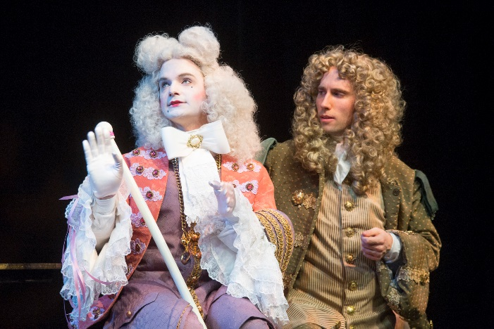
The characters were written as archetypes, they still need to be played as real, personal, and true to you. Callow says you need to identify the archetype you're playing before layering on the character's quirks and contradictions: "The stereotypes have to be recognized and embraced before they can be embellished." As Callow writes, "It is crucial to find the reality of these people and not attempt a cartoonlike theatrical stylization."
The Rake: a carefree, witty, sexually irresistible aristocrat, who combined riotous living with intellectual pursuits and patronage of the arts.
The Fop a pejorative term for a foolish man overly concerned with his appearance and clothes.
The Ideal Gentleman was well born, dressed well, was poised and witty, skilled in love making, was able to conduct several affairs simultaneously, never boasted of his affairs, was always discreet, and never fell in love (or showed true compassion). If he was married, he could not be jealous if his wife took a lover.
The Fashionable Young Lady was familiar with the world of intrigue, but did not become involved in it. If she was a widow (or married to an older man) she could take a lover, as long as she was not found out. If she was married, she should not expect constancy in her husband.
“The heroes of the Restoration comedies were lively gentlemen of the city, profligates and loose livers, with a strong tendency to make love to their neighbors' wives. Husbands and fathers were dull, stupid creatures. The heroines, for the most part, were lovely and pert, too frail for any purpose beyond the glittering tinsel in which they were clothed. Their companions were busybodies and gossips, amorous widows or jealous wives. The intrigues which occupy them are not, on the whole, of so low a nature as those depicted in the Italian court comedies; but still they are sufficiently coarse. Over all the action is the gloss of superficial good breeding and social ease. Only rarely do these creatures betray the traits of sympathy, faithfulness, kindness, honesty, or loyalty. They follow a life of pleasure, bored, but yawning behind a delicate fan or a kerchief of lace.”
http://www.theatrehistory.com/british/restoration_drama_001.html

Restoration Stage
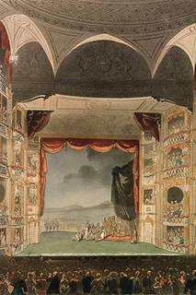
Theatres of the seventeenth and eighteenth centuries were considerably smaller than the Elizabethan theatre (they held around 500 people), and performances took place in closed rooms with artificial lighting. In contrast to modern theatres where the audience sits in the dark, the audience in the Restoration period was seated in a fully illuminated room. One must bear in mind that people of the higher social class were also interested in presenting themselves in public, and attending a play offered just such an opportunity. Because of the lighting arrangements, the division between audience and actors was thus not as clear-cut as today. Plays had the status of a cultural event, and the audience was more homogeneous than in earlier periods, belonging primarily to higher social classes. While the stage was closed in by a decorative frame and the distance between audience and actors was thus enlarged, there was still room for interaction by means of a minor stage jutting out into the auditorium. Furthermore, there was no curtain so that changes of scene had to take place on stage in front of the audience. Restoration plays thus still did not aim at creating a sense of realism but they presented an idealised, highly stylised image of scenery, characters, language and subject matter.
There were scenic innovations developed. Philip Jacques de Loutherbourg was an influential and innovative designer who broke up the floor space with pieces of scenery, giving more depth and dimension to the stage. Other designers experimented with lighting - using candles and large chandeliers which hung over the stage.
Movable flats and painted backdrops were used to resemble the background of various standard scenes. Sometimes the main drape, the curtain that divides the apron from the proscenium, was painted as well. Between the main drape and the backdrops groups of painted flats ran in a series of grooved tracks so that one could be easily pulled out to reveal a new scene on the one behind it. Two additional flats, one off stage right and the other off left, also ran in grooves along the back of the stage in such a way that they could be easily pulled together to hide the original backdrop and form a new back wall for the set. Called shutters, these flats could be easily used in place of a backdrop to create an entirely new scene. The ease in movement created by using flats set in tracks was particularly important to the restoration theater because, at this time, scene changes were still being done in full view of the audience.
Other innovations:
- Foot lights and chandeliers
- Introduced ladders to hold candles – in the wings – thus creating side lighting.
- Trap doors,
- Flying mechanisms
- Perspective scenery
- Experimentation with dimming candle light, using reflectors and coloured glass. Later introduced kerosene lamps which could be dimmed.

Costume, Voice and Movement in Restoration Comedy.
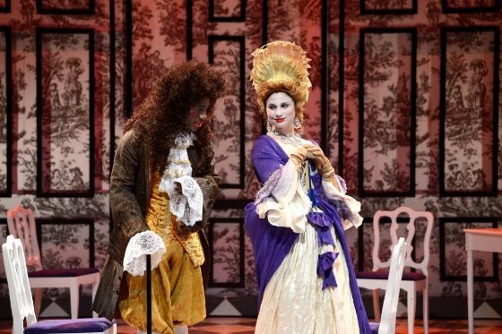
Costumes and accessories dictate movement in specific ways.
A bustle, a corset, and an elaborate headdress necessitate different movement than do your everyday jeans and flip-flops. For men it's the same thing: High-heeled shoes, tight trousers, decorative swords dangling from your waist, and heavy wigs dictate part of your physicality.
Dress was the contemporary dress of the late seventeenth and early eighteenth centuries where every possible part of the body was adorned - large brimmed plumed hat, heavy periwig with curls tumbling over the forehead and down to the shoulders, a square cut coat and a waistcoat hanging to the knees, wide stiff cuffs and ruffles reaching to the knuckles and ribbons on every unmarked surface. (Crawford 1976)
Women wore gowns with bell shaped skirts, bustles and corsets and sleeves with high mantillas and veils. Indoors, women were allowed to show their faces, hands, necks and bosoms, but outside, they wore large hooded cloaks.
Female actors flirted over and behind fans, half-masks and handkerchiefs. Folding fans were used to fan the heat of their escalating passion or to coyly hide behind, among other actions.
Woman balanced enormous and outlandish hats and carried a muff that was used not just for warming the hands but also to carry secret objects such as notes. They walked in a curved, graceful fashion and held their dresses slightly off the floor.
As time progressed, men showed more of their legs (it was considered one of the most attractive parts of a man) and women's attire became more clinging and revealing. The men often wore eye patches.
The fop (an effeminate male) was fashionable and also the butt of much of the sarcastic repartee in the plays. They minced, strutted and used copious flowing hand gestures and posing.
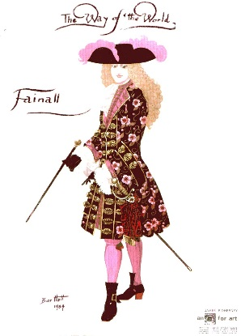
Men always kissed a lady's hand when leaving, held their hands away from their body to emphasize their lace cuffs, handkerchiefs and walking sticks and canes. Embroidered handkerchiefs were used to punctuate speech in various ways.
Both sexes wore excessive make-up, false noses, beards, moustaches, powder, rouge, pencil, lipstick and beauty patches. Facial expression was avoided because it tended to crack the facial make-up. (Crawford)
Callow notes that you'll want to make the clothes work for you, not against you. So, for example, if your gown has a long train, you'll need to kick it out of the way when you want to turn -- and that "can be a very effective form of punctuation." He adds that people of that era used their wigs, bustles, and the like "as natural accessories to their normal human expression."
As Restoration comedies were predominately presentational, movement was focused on entering and exiting through doors. Action took place mainly downstage on the apron of the stage.
Highly graceful and elegant patterns of movement were encouraged and all actions should be precise and inventive.
Gesticulation was very important and an entire array of facial grimacing, winking and smiling was developed.
Women in their stiff bodices and men sat straight up, rarely leaning back against the back of a chair.
Bows and curtsies in the seventeenth century manner were used directed both at other actors and the audience. When one character passed another, they would often perform the en passant, a slight bow from the waist with one foot sweeping in an arc around the other foot without losing the pace of the walk. The basic form of a bow or curtsy is prescribed, but the precise way you do it should not only reveal your attitude toward the person you're greeting (Is he or she socially above you, beneath you, or on your level?) but also be in sync with your objective in the scene. For example, as Callow writes, "If I am bowing to a woman that I desire, I take trouble to make sure she experiences it fully. I catch her with my eye, make her aware that I am perhaps touching the ground as I bow, maybe adding a flourish or two with my hand as I go."
It's not about the right way to walk; it's about interacting with the other characters, about how to impress them, or seduce them.
The voice was brilliant and brittle, witty in language, often prose was used, and rapid repartee was the norm. Actors imitated the Parisian aristocratic style of address with its rich heritage from Moliere. (Crawford, p.230)
Tone was used to convey emotional quality to the audience and precise pronunciation was encouraged. Singing, dancing, posture, gesture and walking were all taught as special training schools in Britain.
Intricate vocal pauses and timing was developed and tempo of delivery was rapid.
Snuff (a mixture of tobacco, herbs and spices and occasionally drugs) was often used by both men and women on stage.

Sources:
http://homepage.smc.edu/martin_ben/TheaterHistory/RestorationTechnicalTheater.htm
http://en.wikipedia.org/wiki/Restoration_comedy
http://www.cwu.edu/~robinsos/ppages/resources/Theatre_History/Theahis_10.html
http://www.london.umb.edu/index.php/entry_detail/restoration_theatre/theatre_intro/
http://dlibrary.acu.edu.au/staffhome/trsanders/units/comedy/comedyofmanners.html
http://www.backstage.com/news/acting-in-restoration-comedy/
Callow, Simon. Acting in Restoration Comedy. Applause Books, 1991. Print.
Crawford, Jerry L., and Joan Moran. Acting, in Person and in Style. Dubuque, IA: W.C. Brown, 1976. Print.

